Electric two-wheel motor, controller and battery information:

Controller:

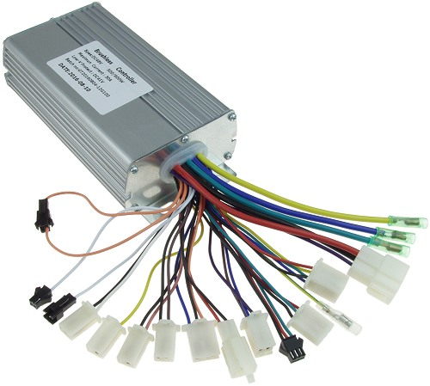

* 48v, 1000w
* Power cutoff: (45v-54v)
* MOSFET:

- In three phase bridge configurations, (3phase*2 MOSFET per phase= 6 MOSFET)

* Microcontroller:

-Texas instrument (TI) C2000 (TMS320F28069)

* HALL SENSOR:

- No. of Hall sensor: 3

-Placement: 120 electrical degrees apart

-Purpose: Provide rotor position feedback for commutation.

* Current Sensors
* Voltage Regulators
* Capacitors and Inductors

BLDC MOTOR:

* Brushless dc motor
* Power supply: 45v-54v
* No. of phase: 3
* Rated rpm: 550
* Rated torque: 30Nm
* Maximum amp consumed without load in full throttle: 2.5amp constant
* Maximum amp consumed with load in full throttle: 4.87amp constant

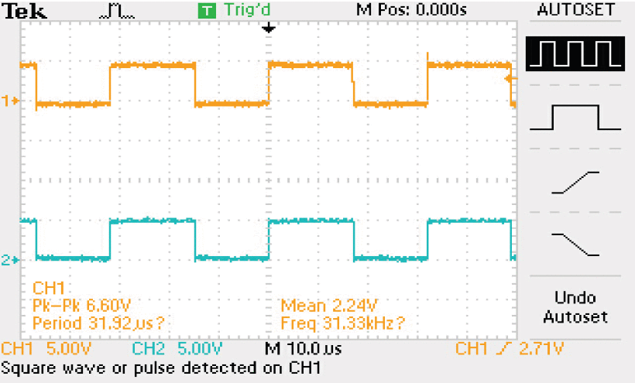 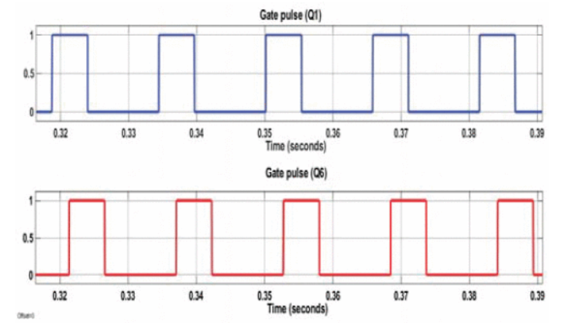

**FIG: Experimental results of PWM output pulses of S1 and S6 with half throttle (hall state 100)**

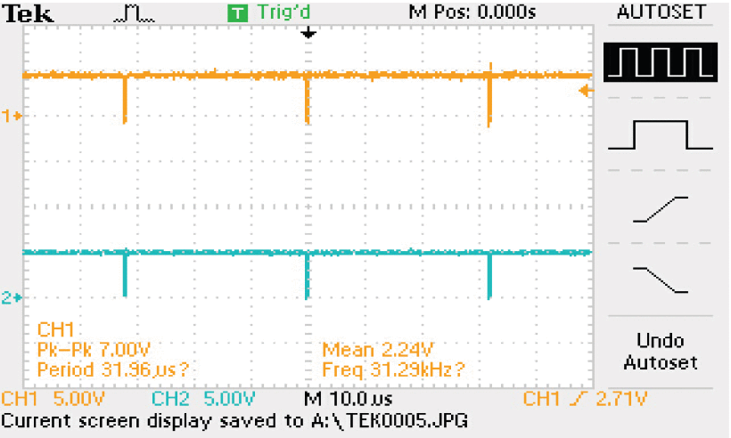 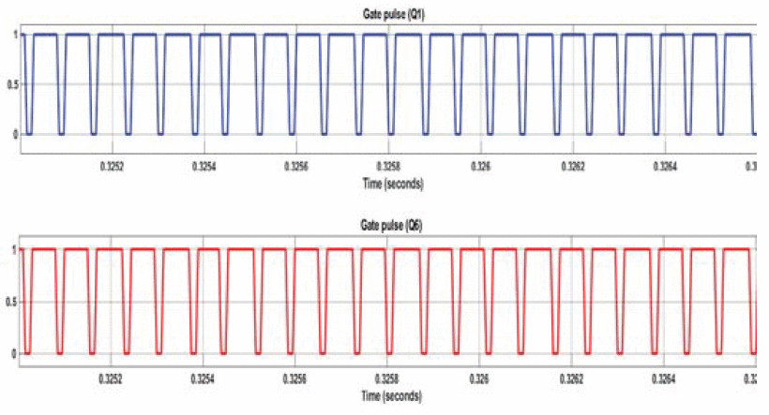

**Fig: Experimental results of PWM output pulses of S1 and S6 with full throttle (hall state 100)**

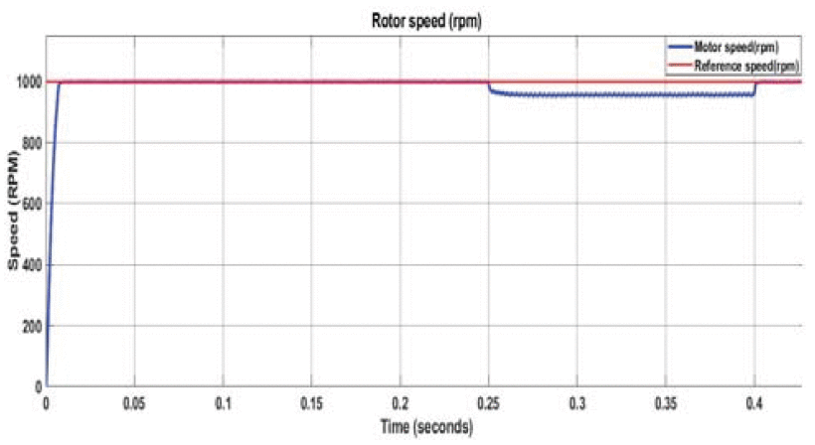

**Fig : Results of speed of BLDC motor (rated load torque of 6Nm at 025 to 04sec (940 rpm) (From Research paper )**

**Battery:**

* Type: Lithium-ion battery cell
* Battery pack of: 48v,25ah
* Each cell: 3.7v (3.4v-4.2v)
* Series Connections: 13 cells in series to achieve 48V
* Parallel Connections: 8 cells in parallel for each series string to achieve 25Ah
* Total Cells=13×8=104 cells
* BMS with 13 cell connection.

[**Thermal Analysis of Li-Ion Battery using Ansys CFD**](https://www.youtube.com/watch?v=EQ4OeMqDeJ4)

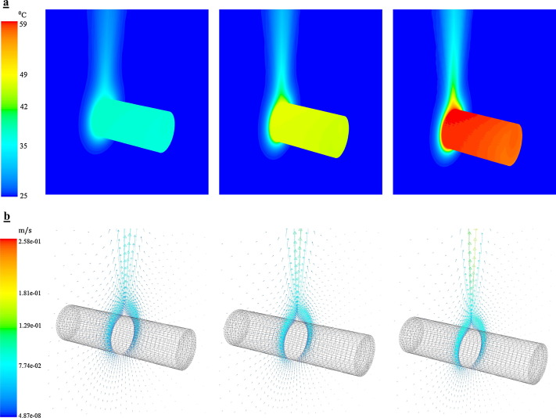

**Fig: Temperature distribution (°C) and velocity profile (m/s) at the end of discharge.**

**Device we used:**

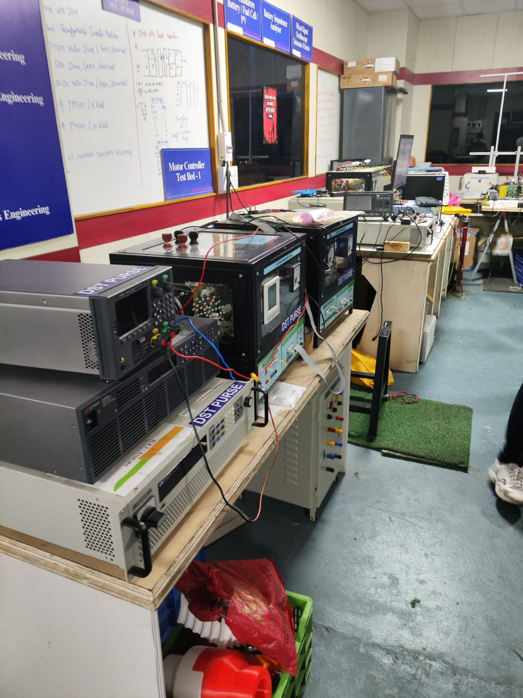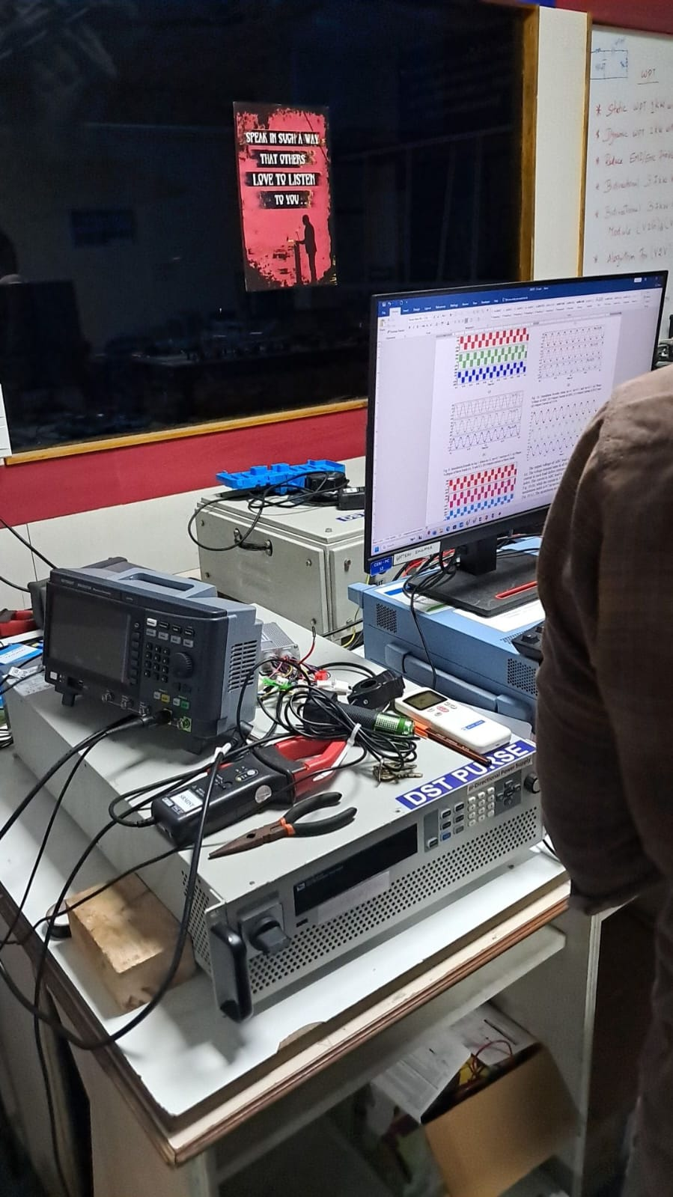

**WIREING DIAGRAM**

